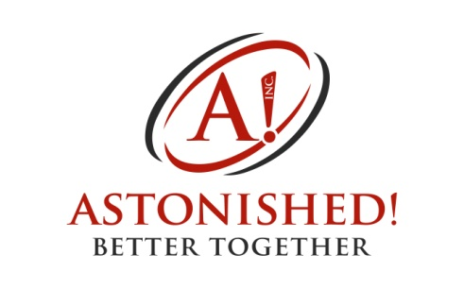

Astonished! Leadership Team
Job Posting
Job Title: Astonished! Leadership Team ~ Team Member
Introduction
Astonished! is a registered non-profit charity based in Regina, Saskatchewan. We work in an inclusive community to address barriers facing young adults with complex physical disAbilities (Core Members) by creating opportunities for teaching and learning; social, recreational and cultural engagement; and for employment and housing.
One program area includes the Astonished! Social Club. Under the supervision and mentorship of the Astonished! Program Coordinator, Astonished! contracts with the Astonished! Leadership Team. This team of young adults, with and without complex physical disAbilities, plans and carries out monthly inclusive, social, recreational, and cultural events for the Astonished! community. Monthly events typically take place in the evenings and/or weekends with each event being approximately 1-3 hours in length. Events will take place virtually or in-person based upon the COVID-19 pandemic and Astonished!’s Response Plan. Example events from years previous include the Winter Games (variety of adapted physical activities and minute-to-win-it competitions), Astonished! Amazing Race Competition, Cougar Hockey games, bowling, local theatre plays, paint nights etc.
We are looking for 3-4 individuals to join the team.
Contract Goal
To work as a team to plan, implement, and evaluate monthly events that further build, grow, and strengthen the Astonished! Community.
Contract Terms and Conditions
Time Frame: September 05, 2022 – April 30, 2023
Payment: Each team member will earn $800.00, which will be paid in 2 installments - the first installment issued halfway through the contract and the final sum issued at the end of the contract. Within the contract time frame, unforeseeable circumstances may arise that cause a team member to miss requirements (events or meetings). Team members may miss a total of 2 requirements within a contract period without penalty. A team member will be docked $50.00 per missed requirement if the team members exceeds the 2 missed requirements quota.
Principal Functions and Responsibilities
- Work collaboratively as a team to plan, promote, implement, and evaluate monthly inclusive social/recreational events based on the strengths, needs and interests of the Astonished! community (September 2021 – April 2022).
- Attend monthly Astonished! Leadership Team meetings in order to plan, promote, and evaluate the monthly events.
  - Some event details may be planned via email and or text messaging. Astonished! Leadership Team Members are expected to respond to email and other forms of communication within 72 hours.
- Arrive a minimum of 30 minutes (in-person) or 15 minutes (virtually) prior to the scheduled start time of the event to prepare for the event and be prepared to stay after the event for post-event clean-up.
- Provide support to Core Members during events to facilitate their participation in the planned activity.
- Socialize with Core Members during events and perform other event duties as outlined in planning meetings.
- Provide support, direction and feedback to event volunteers.
- Events are to be scheduled and posted a minimum of 3 weeks prior to the event to facilitate the needs of the participants.
- Work within the budget outlined by the Astonished! Interim Manager/Executive Director.
- Report to the Executive Director at the end of your term to identify successes, concerns, problems, and areas where more support is required.
- Travel within Regina and nearby cities to make Social Club event content deliveries to our participants.
Support, Mentoring and Supervision
- The Astonished! Program Coordinator will serve as a mentor to the Astonished! Leadership Team and will be at all team meetings and events as needed.
- Members of the Astonished! Leadership Team will be directly accountable to the Astonished! Program Coordinator and indirectly accountable to the Astonished! Interim Manager/Executive Director.
Requirements
- Interest in the commitment to work in an inclusive community to address barriers facing young adults with complex physical disAbilities
- Commitment to build an inclusive community
- Kind, compassionate, and caring
- Criminal record check
- Available in the evenings and on weekends
- Able to travel to a variety of locations in Regina (for meetings, events and deliveries)
- Provide your own attendant if needed
Instructions to Applicants
- Please fill out and forward the application included below to BCV@beingastonished.com with the subject ‘Leadership Team Employment’. We also invite applicants to forward a resume and cover letter.
- Applications will be considered until noon on August 30th, 2022.

Astonished! Leadership Team Application

Personal Information
_________________________________________________________________________
First Name Last Name Middle Initial
_________________________________________________________________________
Present Address
_________________________________________________________________________
City Province Postal Code
_________________________________________________________________________
Phone Number Email Address

In 750 words or less, describe a) what inclusion means to you, b) how you are currently engaged in an inclusive community and c) the value of recreation and social opportunities. In addition, please identify 2 activities you think the Social Club should plan.

